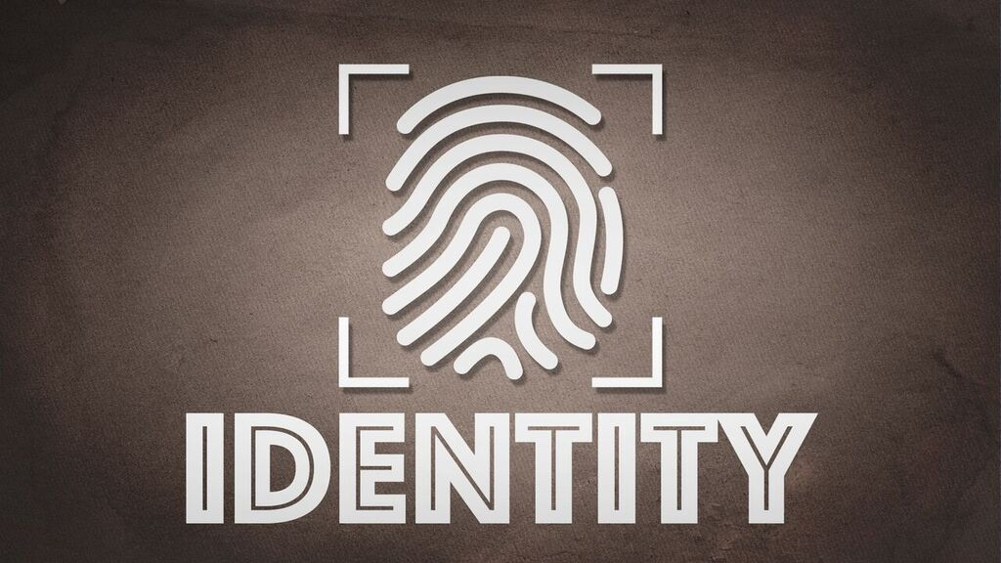

**Identity – Lesson 1**

**IDENTITY**

**Week 1:** Uniquely and Wonderfully Made

**Bible Verses:** Psalm 139:13-17

**Bottom Line:** You are uniquely and wonderfully made by the Creator.

**What’s That to Me?** Students will discover that our identity isn’t what others tell us—it’s what God determined it to be.

**SUPPLIES**

**OPENING ACTIVITY: SELF-PORTRAITS**

* Pens and paper

**TEACH: MADE WITH LOVE AND PURPOSE**

* None

**SMALL GROUPS: WONDERFULLY MADE**

* Ink pads in multiple colors
* Bibles

**LESSON OVERVIEW**

In a pop-culture world, it can be very difficult to accept the way we look, act, or feel. We often try to define our identity through our performance, others’ opinions, or the most recent fad. None of these will reveal our true identity, because our true identity is found through the One who created us!

**OPENING ACTIVITY: SELF-PORTRAITS**

**Supplies:**

* Pens and paper

**What to Do:** This activity may be done in large group or small group. If you plan to discuss the self-portraits, it may be better for this activity to be with smaller groups.

Give each student a blank sheet of paper. Instruct them to draw a stick figure (or a more elaborate drawing) that represents the way they see themselves. After they’ve finished drawing, have them create eight total horizontal lines on the page, with four on each side of the self-portrait.

On the left side, ask students to write four words they would use to describe their appearance—including looks, style, and body type. On the right side, ask students to write four words they would use to describe their personality—such as talents, likes or dislikes, and abilities. Encourage students to be honest with their answers and reassure them they won’t be sharing with anyone else.

**After they’ve written these words, say:** If you look at the words you wrote next to your self-portrait, some may be positive and some may be negative. One day, everything is great, but the next day we want to change our nose, our hair, or our whole body type! We’re so confused! We can look at ourselves every day in the mirror, but it can be hard to really see our identity.

The problem is that we often don’t see what God sees. He is the One who created us just the way He wanted to create us. He doesn’t make mistakes. If we want to find our identity, then we have to look to the One who has uniquely and wonderfully made us!

(Pray, thanking God for creating each preteen just as He has—uniquely and wonderfully.)

**WATCH VIDEO - Week 5 - More than labels**

**TEACH: MADE WITH LOVE AND PURPOSE**

**Supplies:**

* None

**Say:** Today, we’re going to look at what the Bible says about our identity. That’s actually the title of our four-week series—“Identity.”

Every one of us is searching to find out who we are and why we’re here. This is especially true of you and the stage of life that you’re in right now.

During your teenage years, you’re experiencing new emotions, new responsibilities, and new failures. You’re trying to figure out where you fit in at school or at church. Are you a jock? Are you a nerd? Are you a cool kid—or a not-so-cool kid?

Your physical appearance is changing. It’s changing in some ways that you’re happy about, and probably some ways that you’re not so sure about. Your parents are probably giving you a little more independence, but I bet you’re wanting even more!

Show Page - **Definition of Identity**

**Say:** All these things are a part of discovering your **identity**. Identity is *who you are and why you’re here*. If we’re not careful, we can let the wrong things define our identity. Sometimes we try to define our identity based on what pop culture says we should be. Other times we try to define our identity by what our friends think or say about us. But these things will never give us a true definition of our identity. That can only come from the One who created us!

King David had a lot of ups and downs in his life. There were always people—strangers and even his family—who wanted to criticize him. A lot of times, they were fair to criticize because David had screwed up in a big way. Even so, David never let his mistakes or their criticism define his identity.

Show:  **Psalm 139:13-17]**

**Say:** Listen to the words King David wrote in Psalm 139:13-17:

For you created my inmost being;  
    you knit me together in my mother’s womb.  
14I praise you because I am fearfully and wonderfully made;  
    your works are wonderful,  
    I know that full well.  
15My frame was not hidden from you  
    when I was made in the secret place,  
    when I was woven together in the depths of the earth.  
16Your eyes saw my unformed body;  
    all the days ordained for me were written in your book  
    before one of them came to be.  
17How precious to me are your thoughts,God!  
    How vast is the sum of them!

(Read the passage aloud to students.)

**Say:** David understood that his identity could only be defined by the One who created him. David saw how God had created him just the way God wanted to him to be. And the same is true for you and me. God has created us just the way He wanted us to be.

I’m sure there were things about himself that David wished were different. He probably didn’t like something about his appearance. Maybe he had big ears. I’m also pretty sure that David wished he didn’t mess up so many times. But David did not let those things define who he was or why he was here. Instead, David praised God for how he was made.

I challenge you to praise God for the way He made you. So, let’s look at two ways God has designed us and defined our identity*.* First, *God designed us with love.*

[Slide 3: Designed Us With Love]

**Say:** Verse 14 of this passage says, “I praise you because I am fearfully and wonderfully made; your works are wonderful, I know that full well.” And it goes on to say that His works—the things He creates which includes you and me—are wonderful! Some of us have a hard time liking the way we look. We wish we were more like that girl or that guy. We just wish we were different.

The Bible says that God thought of us and loved us before we were even born. He knitted us together and formed us just the way He wanted us. And He says it is wonderful! I’m sure you know this, but there is no one in the whole entire world that is 100% like you.

Even if you have an identical twin, that person may look like you but is not 100% like you. I believe God makes us so unique because He wants us to understand that He knows and loves each and every one of us. He doesn’t just love people as a whole. He loves and cares for each person He has uniquely and wonderfully made. God designed us with love!

And, not only has God designed us in a loving way, He also designed us in a way that fits his plans for us. God *designed us with purpose.*

Show: **Designed Us With Purpose**

**Say:** Verse 16 says that God planned all of our days before we were even born. This means God designed us in a way—a perfect way—so that we could fulfill all the plans He has for us. It may mean that the things you don’t currently like about yourself are just the things that God will use to give you purpose.

God might give you skills in math but make you terrible at Dodgeball. He might make you a great musician, but a slow reader. The point is, God designed you with skills, talents, and interests He can use for His glory. He made you the way you are so you can do the plans He has for you.

As a young girl, Amy Carmichael consistently asked God to change her brown eyes to blue. Her brother had blue eyes, and she wished that her eyes were blue. She would pray and ask God to make that change to her appearance, but it never happened.

As an adult, Amy Carmichael became a missionary who spread the Gospel in India for 55 years. She colored her skin with coffee so she would have the appearance of the natives and be accepted in their culture. This helped her gain their trust and tell them about Jesus Christ.

One day, one of the Christian Indians said, “It’s a good thing that your eyes are brown. If they were any other color, the people of India would not trust you or listen to you. If they were blue, you would be arrested at once, and your work here would be ended.”

Amy realized that God had uniquely created her for a special purpose. As much as she wanted to look different and be different, God had made her according to the plans that He had for her life. And He has made you according to the plans that He has for your life. God designed us with purpose.

We’re all searching to know our identity**—**who we are and why we’re here*.* We look around us to figure it out*,* but we live in a world that is always changing the definition of what is beautiful or popular. So, how can we ever know our true identity?

Show: **The Bottom Line**

**Say:** I challenge you to see yourself as God sees you. He designed you with love and with a purpose. Your appearance, talents, skills, and interests are all a part of God’s perfect design for you. You are uniquely and wonderfully made by the Creator!That is the Bottom Line of today’s lesson. Say it with me!

The Bottom Line: “You are uniquely and wonderfully made by the Creator!”

This is just the first part of our series on Identity, so I hope you’ll be back next week. Let’s talk some more about how we can discover our true identity.

(Close in prayer and dismiss to small groups.)

**SMALL GROUPS: WONDERFULLY MADE**

**Ask students:**

* What are some ways people define themselves (jock, nerd, smart, pretty, and so on)?
* What’s wrong with using pop culture or friends to define our identity?
* Read Psalm 139:13-17. What parts of this verse stick out to you? Why?
* How has God designed us with love?
* How has God designed us with purpose?
* How does seeing God’s design help you to discover your identity?
* What do you think it means to be “uniquely and wonderfully” made?

***ART PIECE (if time allows)***

If your ministry space allows, have all students place their fingerprint on a large cutout of a heart. Allow them to use different color inkpads and more than one fingerprint to completely fill the heart with color. This art piece can stay in your ministry space for the entire series or even longer.)

(Close in prayer.)